3D Printed Movable Tactile Pictures for Children with Visual Impairments to Learn Mobility

| 1st Author Name  Affiliation  Address  e-mail address  Optional phone number | 2nd Author Name  Affiliation  Address  e-mail address  Optional phone number | 3rd Author Name  Affiliation  Address  e-mail address  Optional phone number |
| --- | --- | --- |

# ABSTRACT

Paste the appropriate copyright/license statement here. ACM now supports three different publication options:

* ACM copyright: ACM holds the copyright on the work. This is the historical approach.

This text field is large enough to hold the appropriate release statement assuming it is single-spaced in TimesNewRoman 8 point font. Please do not change or modify the size of this text box.

Every submission will be assigned their own unique DOI string to be included here.

## Author Keywords

Tactile Pictures; 3D Printing; Fabrication

## ACM Classification Keywords

H.5.m. Information interfaces and presentation

# INTRODUCTION

Movable pictures, such as lift-the-flap books are popular in children’s books. They are beneficial for the development of emergent literacy among young children. Figure 1.a. is an example of a movable picture from the book *What’s the opposite?,* a children book that teaches preschoolers opposite spatial concepts such as up/down and lost/found. Pictures in this book are movable in a sense that the paper these pictures are printed on has non-stationary parts children can move with their hands, such as lifting, pulling, and spinning. These movements then cause the visual content of the pictures to change. For example, a child can lift a flap (comforter) and another object (toy), previously hidden underneath the flap, appears. Tangible interactions with movable pictures like this are mostly paper-based with no electronics involved. It is through such interactions children are able to connect kinetic experiences (flipping) with visual experiences (to appears) and learn novel concepts.

For those who visually impaired (VI), however, the benefits of movable pictures are limited. VI children can still obtain the kinetic experiences as they flip, pull, and spin. But they are unable to relate these kinetic experiences to corresponding visual experiences. They are unable to see that a flap is a part of a comforter, or that there is a toy underneath. Without the visual experiences made accessible to them, the kinetic experiences they got are mostly in vain with little or no educational benefit.

3D printing has been shown to be a promising method to make pictures in children’s books accessible to VI children [CITE]. A picture can be 3D modeled as a tactile picture that can be touched, felt, and understood by a blind child. Figure 1.b gives examples of 3D-printed tactile pictures made for *Goodnight Moon,* and *Harold and Purple Crayon*, two children’s book classics.

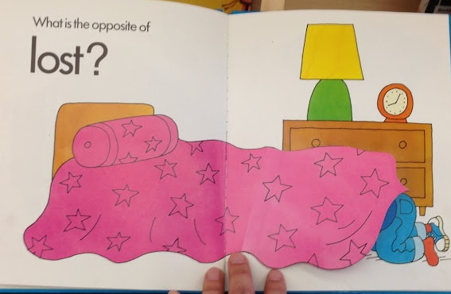 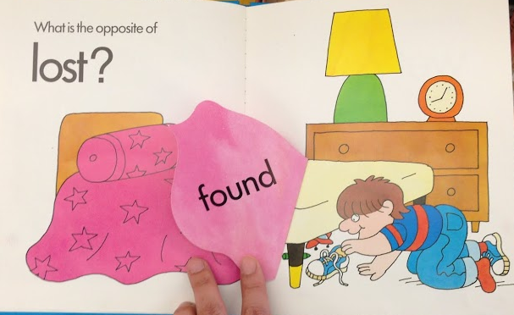

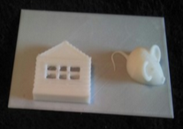 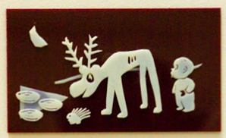

**Figure 1. Movable pictures promote emergent literacy by connecting kinetic experiences (e.g., lifting a comforter) with visual experiences (e.g., discovering a toy) (top). But this connection is broken for blind children because visual experiences are inaccessible. 3D printing makes visual experiences in children’s books accessible to blind children (bottom), but only for static pictures, not for movable pictures.**

However, 3D printing so far has been limited to the creation of static images in children’s books. Techniques previously developed for making static tactile pictures [CITE] may not apply to the making of movable tactile pictures. Movable tactile pictures pose several new challenges. In this paper, we identified three to address:

1. **Moving Primitives:** How can we create tactile models that can be flipped, spin, and pulled by children?
2. **Visual Effects:** How can we make the visual effects accessible in a tactile format as children flips, spins, and pulls?
3. **Reusability:**  To what extent tactile models for moving primitives and visual effects can be reused across many children’s books with movable pictures?

# Related works

3D printing has risen up a promising method for helping parents to replicate tactile books and share designs via online community. [Kim] These tactile pictures books printed in 3D help children with visual impairment develop emergent literacy, by coreading the book with their parents and teachers along with the 3D printed context of each page. [Stangl] They create unique spoken stories according to children’s interests, developing special relationship between them to understand children’s level of literacy development. Qi, et al [Ref] found ground facts that adding mobility and interactivity objects on children book drags children’s curiosity. Physical interaction triggers by push and pull, or spinning attracted children’s interests into the book. However, there is limitation that those interactions gives visual feedback, turning on and off lights, that visually impaired children are not able to see.

# formative studIES

We conducted two formative studies to understand the problem space. Our main goal was to find out how a human designer, who has no expertise on 3D softwares would approach to the task of 3D modeling and printing movable tactile pictures. Informed by the findings we aimed to create an interactive system to support the design process as well as develop the underlying technical and algorithmic components to enable such system.

In our first formative study, we chose to focus on a population with high motivation but without any assumption about their 3D modeling skills. We conducted a design workshop participated by N high-school students who expressed interests in 3D printing. Students were given the task of making a 3D model based on a movable picture in a children’s book. They were also given the freedom to choose their favorite book to model. Instead of using 3D modeling software, students were given a bucket load of Lego bricks to create physical models. Figure shows some tactile movable pictures created by these students.

In our second formative study, we chose to focus on people who are knowledgeable about 3D modeling and laser cutters. The task was to illustrate a picture of a rocket covered by a cloud. The cloud is printed on a flap and can be lifted up to reveal the rocket underneath. We observed and documented the process in which the participants did this design task. Figure below shows some products of their creation. We found the design process consists of the following steps: (1) design curvy clouds, (2) abstract rocket shape in young children level, (3) model a hinge which is mathematically designed to uncover cloud so that not stuck inside during printing, and (4) combine cloud and a rocket with hinge to make the page flappable.

## DESIGN PROCESS

We present a process for creating movable tactile pictures for VI children. This process was informed by our formative studies. The input to this process is a movable picture from a non-tactile children’s book published for sighted children. The output from this process is a 3D-printable movable *tactile* picture aimed to closely approximate the kinetic and visual experiences for VI children. The major steps of this process are:

1. **Interpretation:** A human designer examines the input picture and interprets its visual content as a set of prominent objects and their relationships. For each object, she specifies a 3D tactile model suitable for representing the object. She can either search a 3D model repository (e.g., Thingiverse) or design one from scratch (if she has the skill).
2. **Movements:** She specifies which movement should be associated to each object. She can choose from a set of pre-built moving primitives to add to her design.
3. **Visual effects:** She specifies which visual effect to be triggered by the movement. She can choose from a set of pre-built effect templates. For instance, she can use an “appear effect” template and specify which tactile object to insert into the template.
4. **Synthesis:** Given a set of design choices she has made so far, a computer program can work to automatically synthesize a tactile model, by computing an optimal configuration of moving primitives, visual effect templates, and tactile models.
5. **Customization:** Finally, she reviews the synthesized model and customizes any property she is not satisfied with. Examples of customizable properties include object positions, tactile thickness, and moving directions.

Supporting this process requires us to figure out how to model moving primitives, how to model visual effects, and how models can be reused for synthesis and customization.

# moving primitives

Our first research challenge was to figure out how to model moving primitives. The goal was to derive a common vocabulary of moving primitives that can be applied to as many movable pictures in today’s children’s books as possible. We surveyed N children books with movable pictures and identified four most common classes of movements: hinges, pulleys, spinners, and swings. We went through a number of design iterations and arrived at a vocabulary of ready-to-print moving primitives that can be added to tactile pictures to make them movable. The figure below shows our final 3D models.

|  |  |  |  |
| --- | --- | --- | --- |
| Hinge | Pulley | Spinner | Swing |
| Macintosh HD:Users:qubick:Desktop:Screen Shot 2014-09-02 at 9.39.30 PM.png | Macintosh HD:Users:qubick:Desktop:Screen Shot 2014-09-02 at 9.39.51 PM.png | Macintosh HD:Users:qubick:Desktop:Screen Shot 2014-09-02 at 9.39.39 PM.png | Macintosh HD:Users:qubick:Desktop:Screen Shot 2014-09-02 at 9.40.00 PM.png |

# Figure XX. Four types of moving primitives.

# VISUAL Effects

After developing a set of tactile movable primitives, our next research challenge was to figure out how to combine tactile pictures with these primitives in order to achieve certain *tactile* visual effects. Our approach is to design a set of visual effect templates. Each template is a 3D model that has one or more placeholders for attaching tactile pictures. We found a wide range of visual effects in children’s books. We decided to focus on four common types: appearance, replacement, transformation, and movement.

## Appearance

An *appearance* effect is when an object is initially hidden from a scene and then appears in the scene after a child performed an action. Take a street scene as an example. A car may be initially hidden underneath a flap. After a child lifted the flap, the car appears. In cases like this, only one object is involved. We have developed a tactile template to achieve the appearance effect. This template has one placeholder for a single object. Above the placeholder is a cover that can hide the object. Joining the cover to the canvas is a moving primitive, such as a hinge. To use this template, a designer can choose an appropriate tactile model to represent the object. For example, there are many choices of the tactile cars on Thingiverse to represent a car. A designer may choose one with a simple design she believes most suitable for a blind child. Then, she can insert this model into the placeholder. This is all she needs to do to create a movable tactile picture with an appearance effect. It does not require advanced 3D modeling skill for mechanical components.

|  |  |
| --- | --- |
| Macintosh HD:Users:qubick:Desktop:Screen Shot 2014-09-04 at 10.39.54 PM.png | Macintosh HD:Users:qubick:Desktop:Screen Shot 2014-09-04 at 10.59.08 AM.png |

## Replacement

A *replacement* effect involves two objects. Initially, one object, X, is covered by another object, Y. After a child performed an action, Y disappears and in its place X appears. For instance, a rocket is initially covered by a cloud. After a child lifted the cloud, the rocket underneath is exposed. As a result, the cloud appears to have been replaced by the rocket. This effect can be reversed when a child performed the opposite action (e.g., put down a flap).

We have developed a template to achieve the replacement effect. This template has two placeholders, one for the object above and the other for the object beneath. It is illustrated in the figure below. This template is built upon the template for appearance effect described earlier and has a similar structure. But this template is more complex because (1) a tactile picture can be placed on top of the flap, (2) there are two layers of tactile patterns resulting in greater overall thickness, and (3) the shape of the flap can be irregular (e.g., the shape of a cloud).

|  |  |
| --- | --- |
| Screen Shot 2014-09-02 at 3 | Macintosh HD:Users:qubick:Desktop:Screen Shot 2014-09-04 at 10.35.40 PM.png |

Below is an example of a movable tactile picture created using this template. that can exhibit the replacement effects. Both tip of hinge primitive are combined to the dowel and flags in (a) of Figure XX, to represent flag’s movements in windy whether.

Often, two replacement effects can be combined into one. A good example can be seen in the *Little People Lift the Flap* series. A compound replacement effect typically involves two pairs of objects {X1, X2} and {Y1, Y2} that share the same flap. As a child turns the flap from one side to the other, the child can observe X1 replacing X2 or Y1 replacing Y2. Take for an example a picture of two trees standing side by side. A flap is between the two trees. Initially, both trees appear to have nothing but leaves. By flipping the flap to the other side, the two trees now have an acorn and a squirrel respectively.

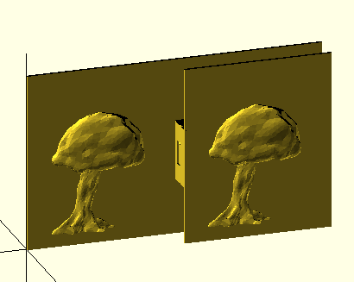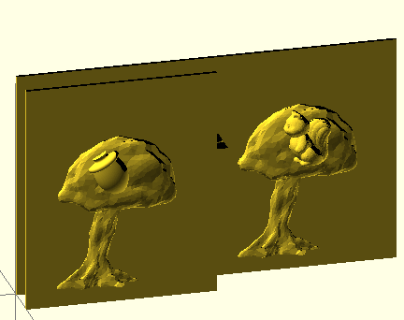

We have developed an extended version of the template to provide four placeholders. The figure below shows the above view of this template (left) and an application of this template to implement the tree example above (right).

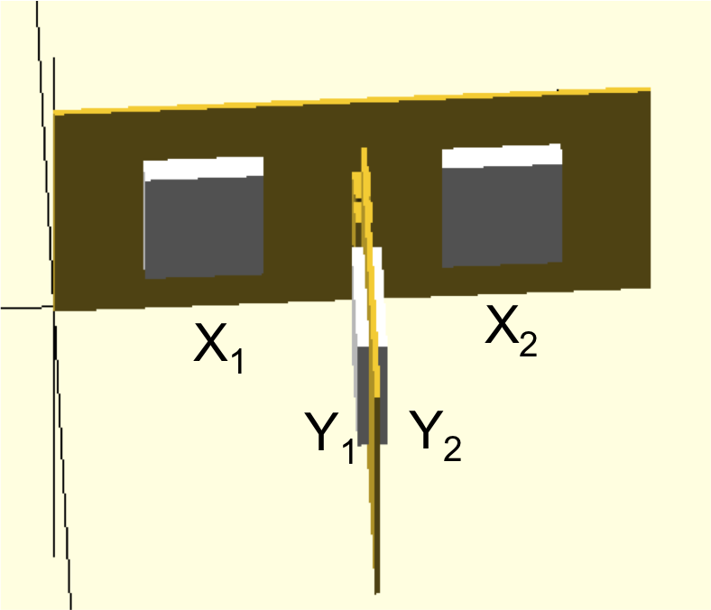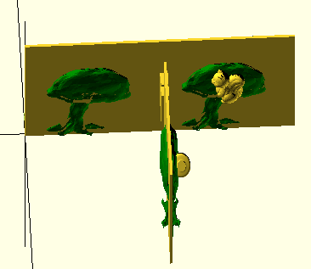

Below are two examples of compound replacement effect.

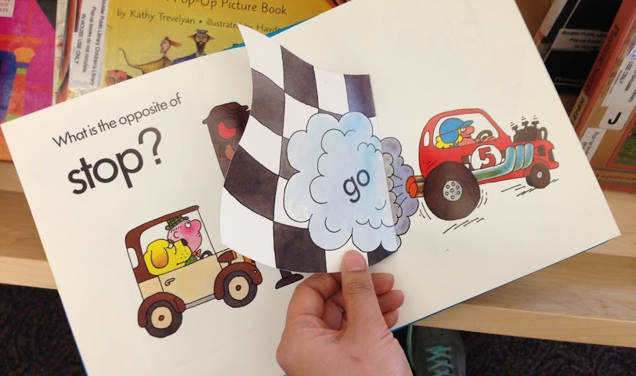 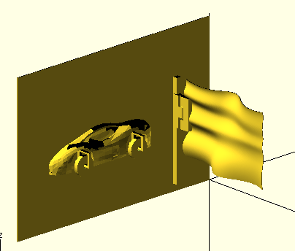

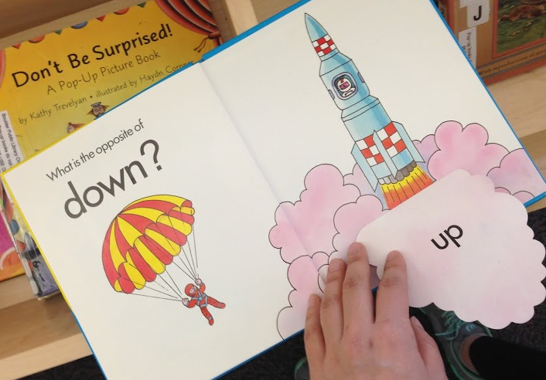 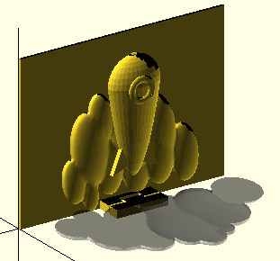

## Transformation

A *transformation* effect is when an object’s appearance is altered as a child performs some action. We observed that in most children’s books, transformation is localized to a portion of an object. For instance, a child lifts a flap and a bunny’s ears become longer.

We have developed a template to achieve transformation effects. In this case, the template has three placeholders. One is for the portion of an object that does not change (i.e., Y, bunny’s head). The other two are for the before and after pictures of the portion of the object that does change (i.e., X, large ear of bunny, and X’, small ear of bunny). The figure below illustrates this template and a specific application of this template to create the bunny example.

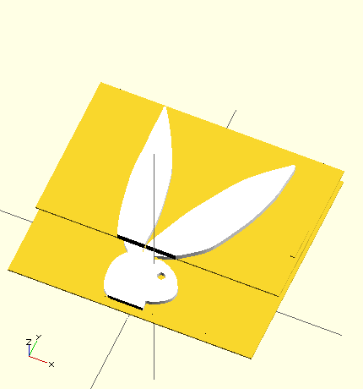 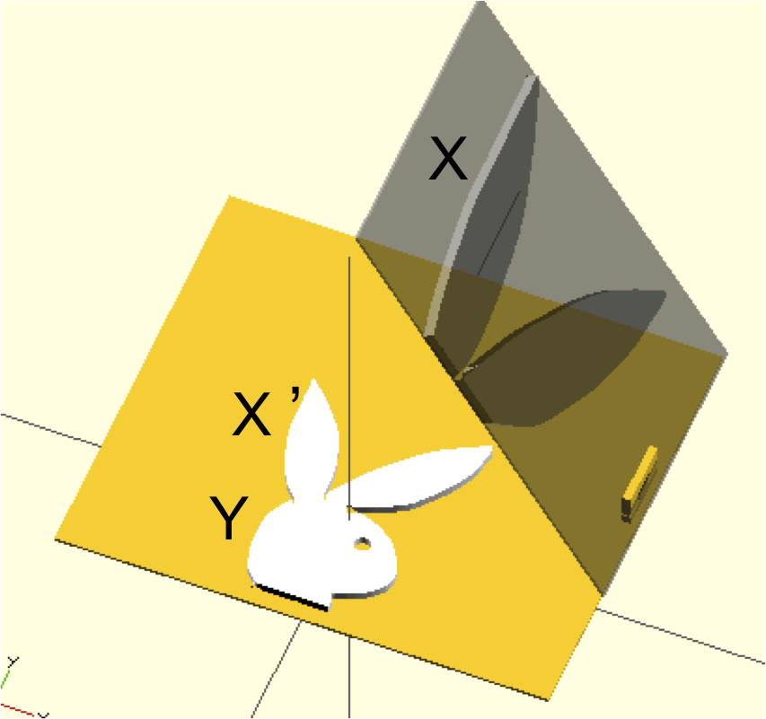

## Movement

A *movement* effect is when an object’s spatial properties are modified without any change to its appearance. For instance, a Ferris wheel’s orientation is changed as a child spins it. A rocket’s height is changed as a child pulls it up. There is often a direct mapping between a child’s hand movement and an object’s movement.

|  |  |  |
| --- | --- | --- |
| Macintosh HD:Users:qubick:Desktop:Screen Shot 2014-09-04 at 11.48.28 AM.png  ***All the Fun of the Fair*** | | Macintosh HD:Users:qubick:Desktop:Screen Shot 2014-09-05 at 12.36.56 AM.png |
| Macintosh HD:Users:qubick:Desktop:Screen Shot 2014-09-04 at 8.59.34 PM.png  ***When I’m BIG*** | Macintosh HD:Users:qubick:Desktop:Screen Shot 2014-09-04 at 4.19.06 PM.pngMacintosh HD:Users:qubick:Desktop:Screen Shot 2014-09-04 at 4.18.57 PM.png | |

Quite often, only a portion of a tactile picture is movable. Below are four examples. The first two examples are based on the book *Maisy Series*. In the first example, only the wheels of a car can be spin by a child. In the second example, a mouse is drinking juice from a cup. A child can pull a pulley to touch and feel the level of juice in the cup is dropping. The third example is a bathroom scene. A pulley is connected to toilet paper to represent the paper is rolling down. In the fourth example, a bird is sitting in a swing attached to a tree branch. It can be swung by a child.

|  |  |
| --- | --- |
| frUHO6Z4El7eRG7Au5vu9HIv8LngJRGN_MZYnHHUbwvLcZnzbDn0sravqwnOMvg0ouRxLbxQ2UROgQsJCtIFGOI7rmrH2PCH2N8A34ctF9r4jpA-P3Rh7TiXtiV1K3tXuQ | Macintosh HD:Users:qubick:Desktop:Screen Shot 2014-09-05 at 12.34.05 AM.png |
| KmOEPKpHwfzB7hpsNJo4pkXbJBAwWh89QNxTHsL7cg9ddsPvk3gDW7sCgBuR5a-ht19AZ-HSXM4kTu5goXe-0OnXBaUX_GmHwWtFVxs5Cmx5m25LNFWfPxF51RnnYeSV0Q | Macintosh HD:Users:qubick:Desktop:Screen Shot 2014-09-05 at 12.38.48 AM.png |
| SMBVGCczoedh1mz5tftpMXb3d9qOn5P9puZ_2v7wIh_x1KVQflnAE0cg-DjDt64fLhcClwaixkPHGKa_NfgVW5LZSyVzMOjJmtib1iEsBP9JbZdxZJ9FQIMEocW3aoJI3w | Macintosh HD:Users:qubick:Desktop:Screen Shot 2014-09-05 at 12.42.24 AM.png |
| Screen Shot 2014-09-02 at 3 | Macintosh HD:Users:qubick:Desktop:Screen Shot 2014-09-04 at 10.58.09 PM.png |

## REUSABILITY

After developing a set of moving primitives and visual effect templates, we set out to tackle our third research challenge, which is to improve the reusability of our models. Reusability is crucial for the synthesis and customization steps of our proposed design process.

The templates can be made using 3D modeling software like Maya or SketckUp. These can be reused as long as the user knows how to use the 3D modeling software. We can have a library of Maya or Sketckup files. A user can load the template model, aimporat a picture, and manually drag the picture to the right place.

However, ideally, we want to automate this placement process and hide the modeling software from end-users. We want to experience to be analogous to ordering a customized photo album online. A user can use a GUI frontend to select a few pictures, then some programmatic magic underneath put these pictures together to synthesize an album, or in our case, a movable tactile picture. It would be very difficult to automate the GUI interaction needed to “drag” pictures to the right places in SketchUp, Maya [CITE], or Blender[CITE]. Thus, to do so, we use OpenSCAD in order to gain programmatic control of the model creation process. We built each template model as a parameterized function in OpenSCAD. Each placeholder is exposed as a parameter to a function. To generate a movable tactile picture is as simple as calling the function with the right parameter. Of course, we do not expect n end user to call this function directly. Rather, having this generative function enables us (or others) to build a GUI frontend. This GUI frontend is not the focus of our paper. But we will offer some design sketches as inspiration. Our focus is the OpenSCAD backend that makes development of a GUI possible.

An example function signature is:

appear\_effect(before\_picture, after\_picture)

combination of (1) newly replaced part of second picture, children inside the door in this particular example, and (2) the entire school house image from the first input image become a first layer of tactile page. If same image is rotated, being shown in different position of in certain angle, this is translated in sway or spinner. Basic mechanism of defining a movement type works either for sway and spinner, since both movements similar but in different angle. If the limit of rotation is given or the angle of rotation is greater than given threshold, it will be defined as spinner, rather than sway.

## Generate Ready to Print STL Files

We developed OpenSCAD code generator that imports STL models searched from the URL using “thing number”, which is unique ID of every single 3D model in Thingiverse. The position, size and kinds of objects from warehouse and including moving primitives are adapted to our code generated as given parameter. Size of parameter defines the general scale of components, and this parameter automatically defines how much the model should be flatten to fit in volume. The system also verifies the model downloaded from warehouse is printable, manifold. Finally, the system renders the entire models, and generates ready to print STL file of the tactile picture.

## Interactive Customization of Tactile Page

In what ways hinge be customized? Size, location, opening…etc. the flap is shaped.

appear\_effect(before\_picture, after\_picture, parameters)

In the basic mode of system, users already get a ready-to-print 3D model. Once 2D visuals as input are scanned, objects which will be put on first layer are searched from online 3D warehouse such as Thingiverse [Ref], SketchUp [Ref] where a lot of practitioners, designers, and hobbyists share their professional 3D designs. Parents and TVIs do never need to design complicated and detailed real life objects. Among tons of designs in different shapes, various abstraction level of detail, etc., they only need to choose the best fitting model to import in the design. By checking appropriate sizes of the objects, users define position of object, reduce or increase the number of object placed elsewhere to add details of scene, resize model interactively. In more sophisticated mode, users can choose the perspective views of the object. For example, in one version of 3D tactile picture, the side view of a bed can be embodied, otherwise, the bottom side of the bed view can be depicted for another version of Figure 2.

To be adapted as part of movable objects, roller was scaled down and copied to be integrated two tires. Roller was maximized the size to fit into large frame of a giant wheel in the second example. Parents and teachers co-read the story and children with visual impairments can touch and feel cylinder with a hole is moving around an axe, and they may interact following narratives. Numerous application ideas will rise, such as lids of a jar, LP record panel spinning over gramophone.

# EVALUATION

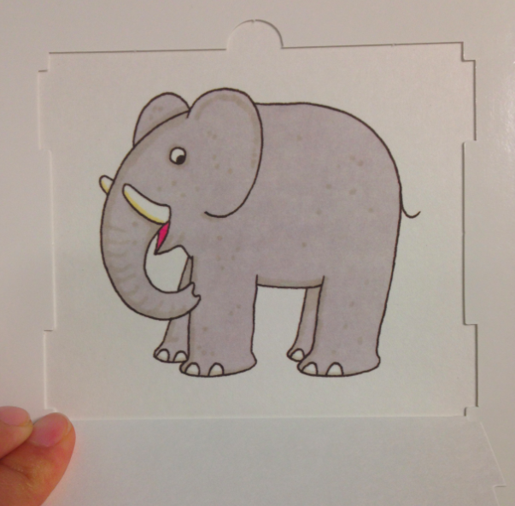 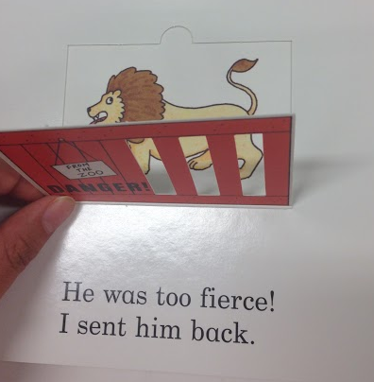 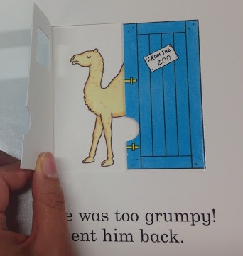 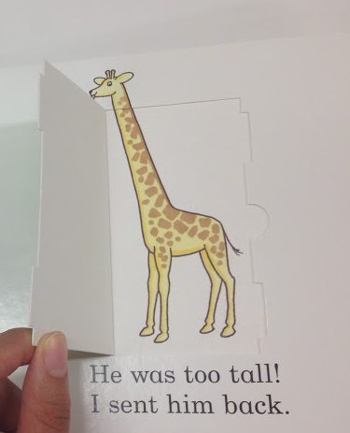 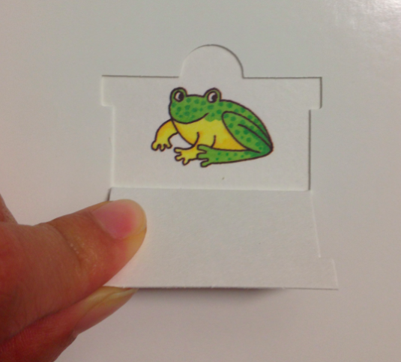 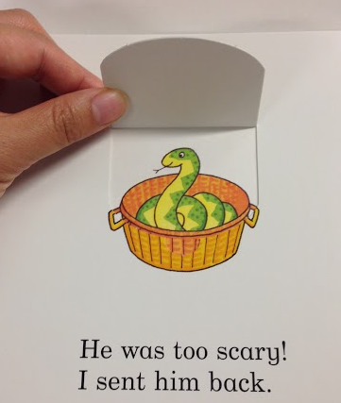 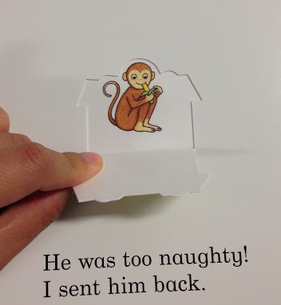 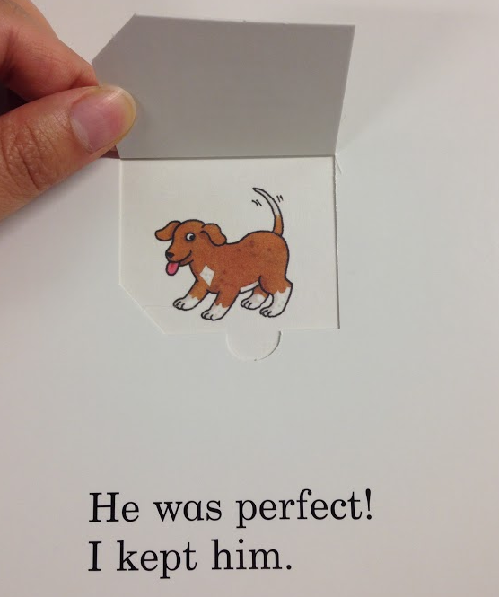

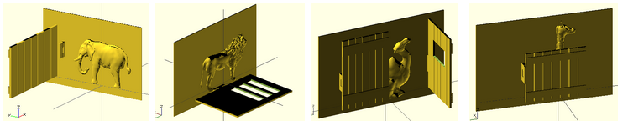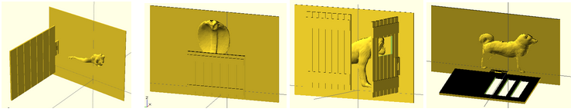

**(a) Elephant with a door flapping left (b) Lion with a door flapping down that has ribs   (c) Camel with two doors fliapping in two direction, and with window in the middle (d) Giraffe with a lower door showing its head over the door.** Four pictures following are variations of previous pictures **(e) Frog (f) snake heading above a door, (g) monkey with two door, and (f) dog with flap down door**

**Figure 6. Eight different animal pictures with flap part of *Dear Zoo* (above) and movable tactile representations (below)**

**Dear Zoo - Reusability**

We transcribed the *Dear Zoo* into 3D movable tactile pictures book, as a whole set of the picture book. This was a book chosen by our workshop participants during our formative studies. The story is focusing on very simple conception of the kinds of animal children can see from the zoo, and 2D visuals of them emphasizes features of each animal in terms of size. This is a good example book to be tested by our system, since the *Dear Zoo* is one of the most loved lift-the-flap books that manipulates simple interaction mechanism repetitively such as opening the boxes. For our users, parents need only differentiate the kinds of animal and size of the box. Optionally, the kinds of the door, which is done by changing various doors with different hinge position, lets their children to open the door in different directions. Figure 5 shows eight pages of animal with flap from the book and 3D representation of each page. Figure 5 shows eight pages of animal with flap from the book and 3D representation of each page.

## Applications of Primitives with Different Books

## Printability

Mention we sent to 3D hub to test how printable our models are.

## Design Process

We invited a mid-level expert of 3D design to explorer page variations of “Dear Zoo” book. We gave a parameter of (1) kinds of animal choice, (2) size of animal, (3) size of the door, and (4) kinds of door. He chose animals based on selection criteria, shapes and complexity of the model. Even though the animal design from online 3D warehouse looks good, if the model is too high poly, he changed his selection because it takes too long to re-render from OpenSCAD generator to get final STL file to print out. He changed the door size widely for the frog model, to fully cover the frog on the page when the flap is closed. In the same way, he scaled animal size to fit in given page back size, neither too big, nor too small, considering tactility of touch. Basically he randomly applied kinds of the door, but changed the design into side opening door if scaled animal design is too tall so that down hinge is overraped with animal’s legs.

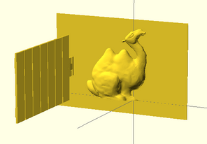 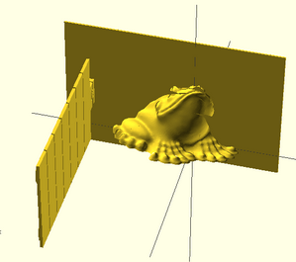 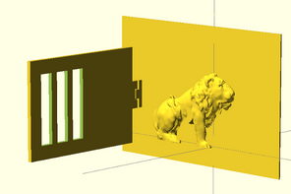 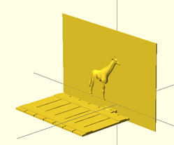

**Figure 9. Four variations of animal with different design, size, and door types.**

# Conclusion

# REFERENCES

1. Jie qi, Leah Buchery, Electronic Popables: Exploring Paper-Based Computing through an Interactive Pop-Up Book, TEI 2009
2. Kim J., Stangl A., Eisenberg A., Yeh T., Tactile Picture Books for Young Children with Visual Impairment, TEI 2014
3. Lipson H, Kurman M, Fabricated: The New World of 3D Printing p.271-275
4. Stangl A., Kim J., Yeh T., Technology for emergent literacy, IDC 2014
5. Google SketchUp 3D Warehouse https://3dwarehouse.sketchup.com/
6. MakerBot Thingiverse http://thingiverse.com
7. Go, Maisy, go!
8. Goodnight Moon
9. Harold and Purple Crayon
10. All the Fun of the Fair
11. Eric Hill, What’s the opposite?
12. Dear Zoo
13. Oliver Dunrea, Gossie Playes Hide and See

14. Paula Hannigan, When I’m BIG